HW 8.0-TK-Hillel-BA IT-ENG-Research results

* В Miro создайте Story map по функциональности, над которой вы работаете
* Опишите целевую/ые группу/ы ИЛИ портрет/ы пользователя/ей (6 занятие) по результатам проведенных исследований.
  + Для выполнения задания можете использовать специализированные приложения (см. материалы занятия) либо Miro

1. Create a Story Map on the functionality you currently work with:

The following stories were selected for practicing purposes:

* As a bank customer, I want to be able to access my accounts online from my smartphone in order to save time on calling and/or going to the bank.
* As a user of the application, I want to be able to enter the application using a biometric scanner so not to enter a username and password every time I use the application.
* As a bank customer, I want to be able to transfer funds via a smartphone so not to waste time going to the bank or using third-party resources (sites or terminals of payment systems).
* As a bank customer, I want to be able to find out the current exchange rates right in the application so not to waste time looking for similar information on other resources.

Story map view:

<https://miro.com/app/board/o9J_l_sLzvQ=/>

or

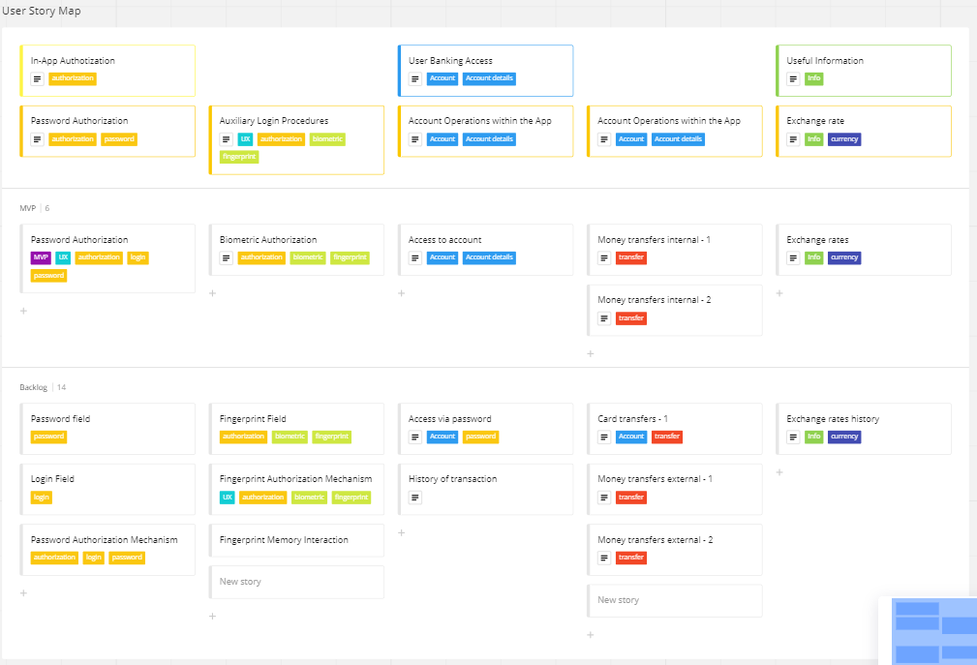

1. Describe the target group(s) or the user portrait(s) based on the results of the research:

Anna 

* 1. Demo
     1. Age: 26
     2. Status: Married, mom of two (3-years old boy and 3-month old girl)
     3. Income level: maternity leave, depends on husband’s incomes
     4. Residence area: Odesa region
     5. Education: Master’s Degree in Audit and Accounting, Master’s Degree in Management,
  2. Activities/Behavior
     1. has no time for time-consuming procedures (queues, document-supported procedures, registrations etc.) due to constant business with two small kids
     2. lives “in the phone”, meaning uses a lot of various applications for simplifying the life of a busy mother, including the mobile banking application
     3. prefers to buy products and services online via G-Pay, Privat24 or RBA mobile applications
     4. Receives pension for children to RBA pension card and controls the related activities via RBA mobile application
  3. Needs/Goals
     1. Needs to have a reliable and swiftly-operating mobile banking app with user-friendly interface and well-functional banking procedures for purchase of goods or services, utilities payments, money transfers etc.
     2. Would like to have a built-in reminder/memorizer service within the mobile banking application for certain periodical payments/transfers to be made
     3. Would like to have automatically extended or expiry-less pay or credit cards for the next three years
     4. Would like to have possibility to manage deposits online via the smartphone
     5. Would like to receive sales and discounts proposals on favorite goods for domestic economy
  4. Experience/Knowledge
     1. Has quite limited knowledge on the functioning of mobile banking application and banking products,
     2. Has quite limited time resource to get acquainted with the product features or additional documentation on current/new services and products provided by the bank via the app.
     3. Uses RBA payment cards for several years already, especially for online payments and shopping.
  5. Problems/Fears
     1. Limited time resource leaves no chance for familiarization with the latest or improved bank products or services via reading the documentation.
     2. Seeks for platforms and shops providing golden triggers like “sales”, “discount” or “promotion” for the goods for healthcare, childcare and of domestic economy purposes.
     3. Prefers platforms and online-shopping transactions with quick payments available via Privat24 or a direct link, that is so far a seldom practice in Ukraine, and platforms providing it aren’t cheep.
     4. Afraid of hidden payments and commissions at some payments/transfers provides.
     5. Prefers shopping positions with delivery and commission included/covered by the provider of service.
  6. Relation/Impact
     1. Uses RBA pay card due to the comfortable allocation of ATM,
     2. Uses RBA ATB pay card due to the discounts provided within the partner program between RBA and ATB.
     3. Spreads the word about the RBA+ATB feature
     4. Spreads the word about the constant availability of money in RBA ATMs and lack of hidden commission within the services provided by RBA.